

Prepared for

**Contoso**

Project

**Microsoft Dynamics AX Implementation**

Prepared by

**Brian Burke**

Contributors

**Monica Brink**

**Table of Contents**

1 Technical Design Planning 2

Overview 2

Timetable 2

Roles and Responsibilities 2

2 Review Design Document 3

3 Document User Interface 4

Forms 4

4 Define Process 6

Validation Options 6

5 Define Data Modifications 7

6 Dependencies and Assumptions 8

7 Security Strategy Summary 9

Security Requirements 9

Security Plan 9

Roles-based Security Matrix 9

**Revision and Signoff Sheet**

|  |  |  |
| --- | --- | --- |
| Date | Editor | Revision Notes |
| 03/22/2008 | Brian Burke | Initial draft for review/discussion |
|  |  |  |
|  |  |  |

# Technical Design Planning

## Overview

Microsoft Dynamics AX functional and technical understanding is needed to plan this Technical Design Document. A developer needs to know how the AX functional part works and what options will affect functionality of other forms or processing. The AX AOT is used to add new or modify existing objects, elements. AOT expert understanding will help to develop a solution with least amount of changes.

## Timetable

1. Study of functional document
2. Discussion with functional consultant
3. Study of Existing development
4. Determine what needs to be added or changed.
5. Estimate the timeframe to do development, testing and re-work and re-test

## Roles and Responsibilities

The AX Developer/Designer will create this document and estimate the time needed to develop and test and potentially re-work and re-test. Once it is in the Development Environment and has been approved, the modification will be migrated to the Test Environment for further testing. Upon approval, the modification will be migrated to the Production Environment.

# Review Design Document

Contoso’s purchasing department often orders product based on a vendor minimum order value in order to receive a multiplier discount. A developer will modify the AX Vendor form and Purchase order form to reflect the minimum order value for any specified vendor and display it onto a Purchase order. Should the user try to Post the purchase requisition, an info log will be displayed stating that the vendor minimum order value has not been met. The vendor minimum will be displayed onto the purchase order as well as a running total (net value) of the purchase order for a visual reference.

NOTE: Further details can be reviewed within the corresponding Functional Design Document.

# Document User Interface

## Forms

**Forms: VendParameters, VendTable, PurchTable**

**New group: Vendor Minimums**

**F1:** Create new checkbox parameter on Purchase order tab labeled “**Use Vendor Minimum**?” When clicked, this will enable the new field “**Vendor min amount**”. This checkbox will also be copied from the vendor record onto the Purchase order header as a display only.

**F2:** Create new field to be placed beneath F1 labeled “**Vendor min amount**”. When a value is entered into this field, it will be copied onto the Purchase order new field “**Vendor minimum**” as a display only.

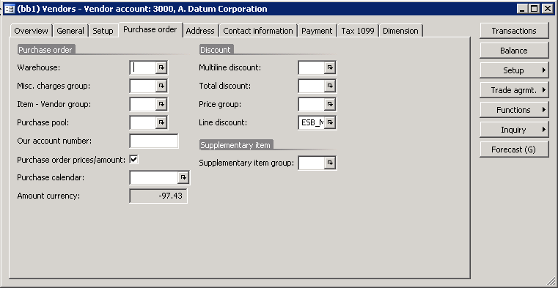

F1: Checkbox

F2: Amount

### Purchase Table / Form:

**F3:** Create a new display field on the Purchase order header > Setup tab that displays the value set in **F1**. If the value is set to true, populate **F4.**

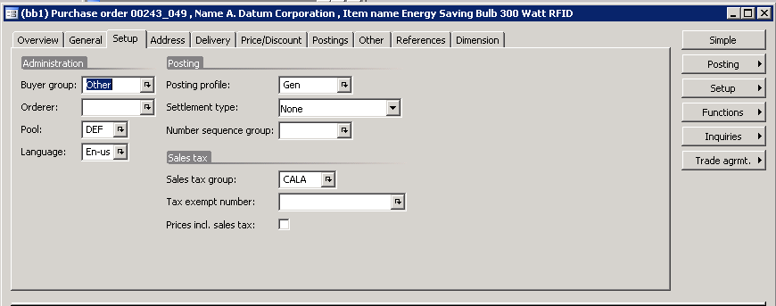

F3: display F1

**F4:** Create new display field on the Purchase order header beneath the buttons labeled “Vendor minimum” that displays the value entered in **F2.**

**F5:**  Create new display field on the Purchase order header > beneath **F4** labeled “Total Net”. This field will be a calculation (sum) for all PurchLine**.**LineAmount on this order.

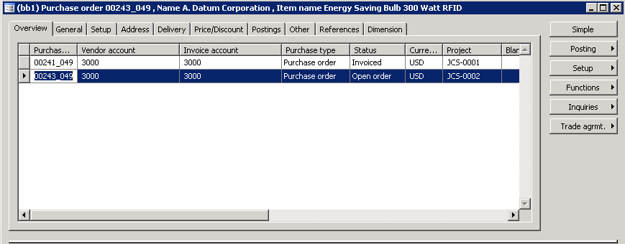

F5: Calc - display

F4: display F2

# Define Process

Validation of minimum amount will be based on Parameter form and can be further overridden at the vendor table form. Minimum order Amount limit is controlled from Vendor table form. The field values minimum amount and uses minimum amount check field that will be transferred to Purchase order form. Based on purchase line amount running total and use minimum amount check option, when posting of the purchase order is attempted. System will validate based on conditions if a message needs to be displayed and posting to be stopped. Message to be displayed after condition not met is “The vendor minimum order value has not been met.”

## Validation Options

The Validation Options will in the “Use Minimum Amount check box” and the “Minimum Order Amount.”

Message

When the validation fails, the system will halt processing and display message as “The vendor minimum order value has not been met.”

# Define Data Modifications

### Modified Tables

**Table Name: VendParameters, VendTable, PurchTable**

There will be new fields in VendParameters, VendTable and PurchTable. Data will be populated from VendParameter and Purchtable data will be initialized from initFormPurchTable based on VendTable. When Posting is taking place, data will be validated at PurchFromLetter class using Validate method. Validate method will control message.

**Modified or New Fields:**

|  |  |  |  |
| --- | --- | --- | --- |
| **Field Label:** | **Help Text:** | **EDT/Type:** | **Notes:** |
| **Use Vendor Minimum** |  | Enum NoYesId | All 3 Tables |
| **Vendor Min Amount** |  | EDT PurchLIneAmount | VendTable and PurchTable |
| **Display Total Net** |  | Display Method | PurchLineAmount |
| **initFromPurchTable** |  |  | Method on PurchTable |

### Enumerated Data Types

**New EDT’s:**

|  |  |  |  |
| --- | --- | --- | --- |
| **EDT:** | **Help Text:** | **Type:** | **Extends/Attributes:** |
| **Use Vendor Minimum** |  |  | NoYesId |
| **Vendor Min Amount** |  |  | PurchLineAmount |
|  |  |  |  |

**Class Name:**

PurchFormLetter

Existing Method Validate

New Method LineAmountMinimumCheck

**Class change description**

Method Validate is standard method in class PurchFormLetter, this method is always called before any type of purchase order posting is initiated. LineAmountMinimumCheck will be called from Validate method. LineAmountMinimumCheck is a new method, which will return success or failure of validation, based on functional design document requirement. This method will also display required message.

# Dependencies and Assumptions

**Assumptions:** Vendor Parameter form option Use Minimum Amount Enable option set, at least one vendor created , Vendor will get option defaulted from vendor parameter only when option is set before creating new vendor, else vendor option needs to be independently set. Even though parameter option is set, it can be overridden by independently setting for each vendor.

**Dependencies:** Posting message and validation depends on Vendor parameter option enabled and further vendor option enabled.

# Security Strategy Summary

## Security Requirements

There has been no specialized Security Requirements requested.

## Security Plan

There has been no Security Plan requested so standard Microsoft Dynamics AX Security rules will take effect.

## Roles-based Security Matrix

Based on standard options the Vendor Parameter Form, Vendor Table and Purchase Order Form security will be set and field level security for VendorParameter, VendorTable, PurchaseTables can be added if needed.